RESQAI: AI-BASED ACCIDENT DETECTION, SEVERITY ASSESSMENT AND INTELLIGENT EMERGENCY RESPONSE SYSTEM
Design and Implementation
Department of Computer Science and Engineering, TKR College of Engineering & Technology
Batch A2 (CSE-A) · Academic year [ACADEMIC YEAR]
Table 1: Project team
S.No. | Student name | Roll number
1 | Adepu Meenakshi | 23K91A0503
2 | Ayila Shanmukha Sai | 23K91A0521
3 | Chekka Chandrashekhar | 23K91A0552
4 | Avula Sreeya | 23K91A0519

Project guide: Shirisha Reddy
Chapter and section numbers quoted in the text (for example Chapter 8 or Section 6.2) refer to the full project report, 17.Final Document. Figures and tables in this document are numbered from 1.

1. DESIGN
This chapter turns the requirements of Chapter 4 into a design. It gives the architecture, the workflow of one event from sensor reading to dispatched alert, the data flow diagrams, the UML models, the data design, the module design, the algorithm design, the interface design and the reasons for the main design decisions. Every diagram was drawn from the code in the repository (app.py, auth.py, train_models.py, data/ and frontend/src) and each is listed again, with a short explanation, in the block-diagram document. Where the design is simpler than a production system would need, the chapter says so; Chapter 10 lists the corresponding future work.

1.1 Design Goals and Architecture
Four goals shaped the design. The first is end-to-end completeness: the base paper and the other surveyed work stop at predicting severity from recorded crash data, whereas the problem statement asks for a loop that runs from sensing to a located, prioritised alert. The second is false-alarm control: an alert that reaches responders for a pothole or a hard stop costs trust, so a human confirmation step sits between the model and the alert. The third is demonstrability without hardware: no phone, vehicle or crash-test data was available, so the sensing stage is simulated by the backend and everything after it is real code. The fourth is simplicity of deployment: the application runs from one batch file on an ordinary Windows machine, with no database server and no cloud account.
The architecture has four tiers (see the figure below). The presentation tier is a React 19 and Vite 8 single-page application on port 5302. Its three console screens (live monitor, manual override, emergency response) share one state provider, MonitorContext, which owns the sensor history, the event log, the 15-second countdown and the dispatch result, and the only network code is the thin fetch wrapper in lib/api.js, which attaches the Bearer token and turns failures into a typed ApiError. The application tier is one Flask 3 process on port 8302: app.py holds the five working endpoints and the helper functions, and auth.py is a blueprint that adds registration, login and an optional guard. The machine-learning tier is a scaler and two random forests loaded once at import time with joblib; if a pickle is missing the application sets MODELS_LOADED = False and answers from a three-threshold rule instead, so it never fails to respond. The data tier is two JSON files and four pickles; there is no database.
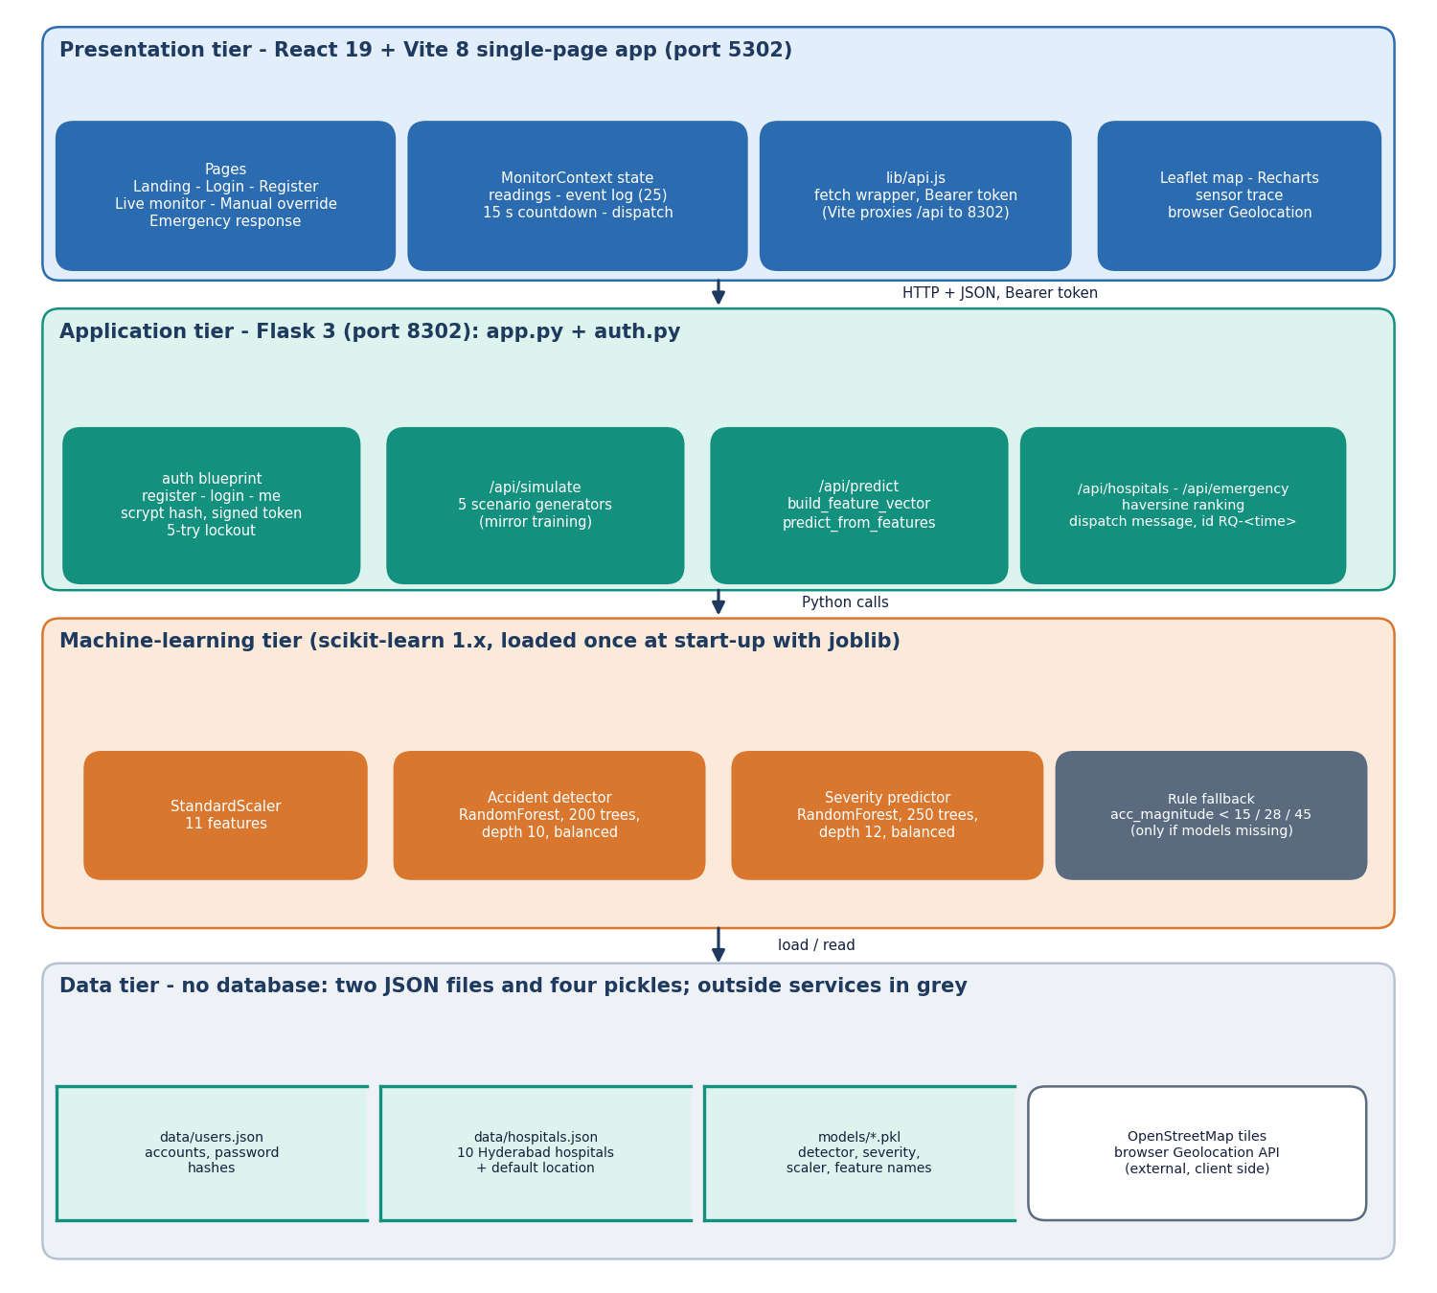
Figure 1: Four-tier architecture of ResQAI: React console, Flask API, machine-learning tier and file-based data tier.
The tiers talk only in one direction through narrow interfaces. The browser sends JSON over HTTP and, when the optional guard is on, a signed Bearer token; the Vite development server proxies every /api request to the Flask port, which removes the need for cross-origin settings. The Flask process calls the models through ordinary Python calls. The only outside services are OpenStreetMap map tiles, which the Leaflet map requests from the browser, and the browser's own Geolocation API; neither is part of the server.
Table 2: Technology used by tier
Tier | Technology | Role
Presentation | React 19, Vite 8, React Router 7, Recharts, Leaflet, framer-motion, GSAP | pages, sensor chart, map, animations, theme
Application | Python 3.11, Flask 3.1, itsdangerous, werkzeug.security | REST endpoints, accounts, signed tokens
Machine learning | scikit-learn (RandomForestClassifier, StandardScaler), NumPy, pandas, joblib | detection, severity grading, persistence
Data | JSON files (users.json, hospitals.json), pickles (models/) | accounts, hospital directory, trained models
Tooling | Playwright, scripts/smoke_test.py, scripts/run_tests.py | screen capture, regression and security checks

1.2 High-Level Workflow
The figure below follows one event through the system. A reading of eleven features is produced; in a deployment the phone would supply it, here the backend's /api/simulate does. The reading is posted to /api/predict, where it is turned into a feature vector, scaled, and passed to the detector and the severity model. The browser then applies the rule that decides whether a person must be asked: only a Moderate or Severe grade opens the confirmation dialog, and a Minor crash or a normal reading is only written to the event log.
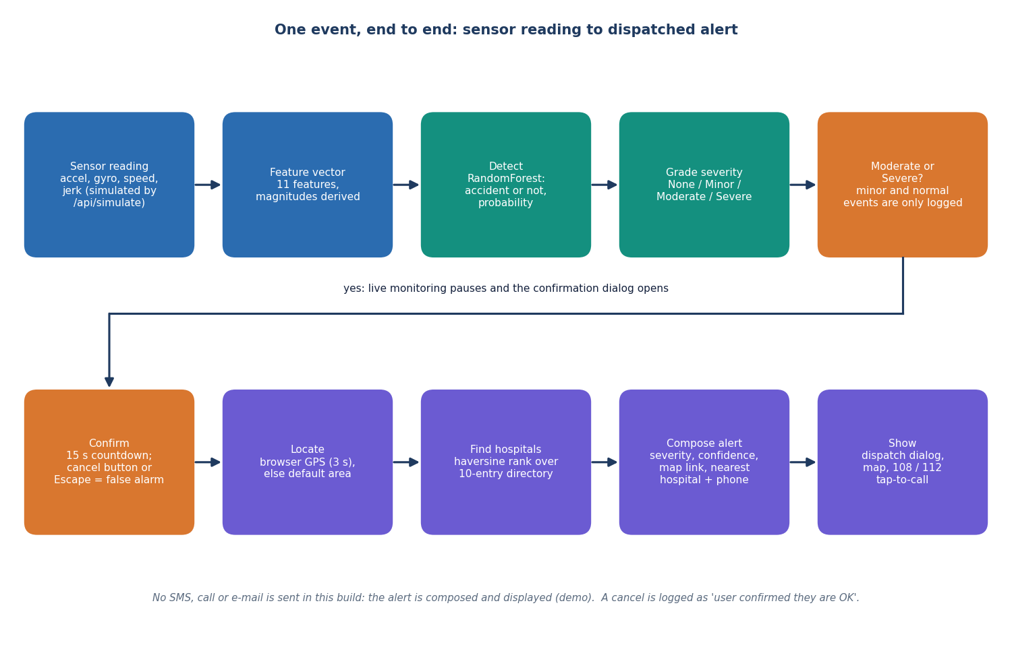
Figure 2: High-level workflow of one event, from the sensor reading to the dispatched alert.
The numbered steps below are the behaviour of the console, taken from MonitorContext.jsx:
1. The occupant presses a scenario button, starts live monitoring (one reading every 1.5 seconds, never two requests in flight) or submits manual values.
2. The reading is sent to POST /api/predict; the response (accident flag, severity label, probability, the features used, the model source) is stored as the current result, a point is added to the sensor trace (the last 40 are kept) and a line is added to the event log (the last 25 are kept).
3. If the label is Moderate or Severe and no alert is already pending, the result becomes the pending alert, live monitoring is stopped, and a dialog with a countdown from 15 seconds opens.
4. The occupant can answer I'm fine, cancel or press Escape; either counts as a response, the pending alert is cleared and the event log records that the user confirmed they are all right.
5. If the counter reaches zero, or the occupant presses Send alert now, the browser asks for its position (three-second timeout) and posts the severity, the confidence and, when known, the latitude and longitude to POST /api/emergency.
6. The server ranks the hospitals, composes the dispatch message and returns it with an alert id; the dispatch dialog opens, the Emergency response screen draws the map, and the event log records the alert.
Nothing leaves the machine in step 6. The dispatch message is drafted and shown, with a copy button and tap-to-call links for 108, 112 and 103, and the interface states that the demo does not contact responders. This is the main gap between the system as built and the sixth objective's wording about dispatching to emergency contacts, and it is repeated in the limitations.
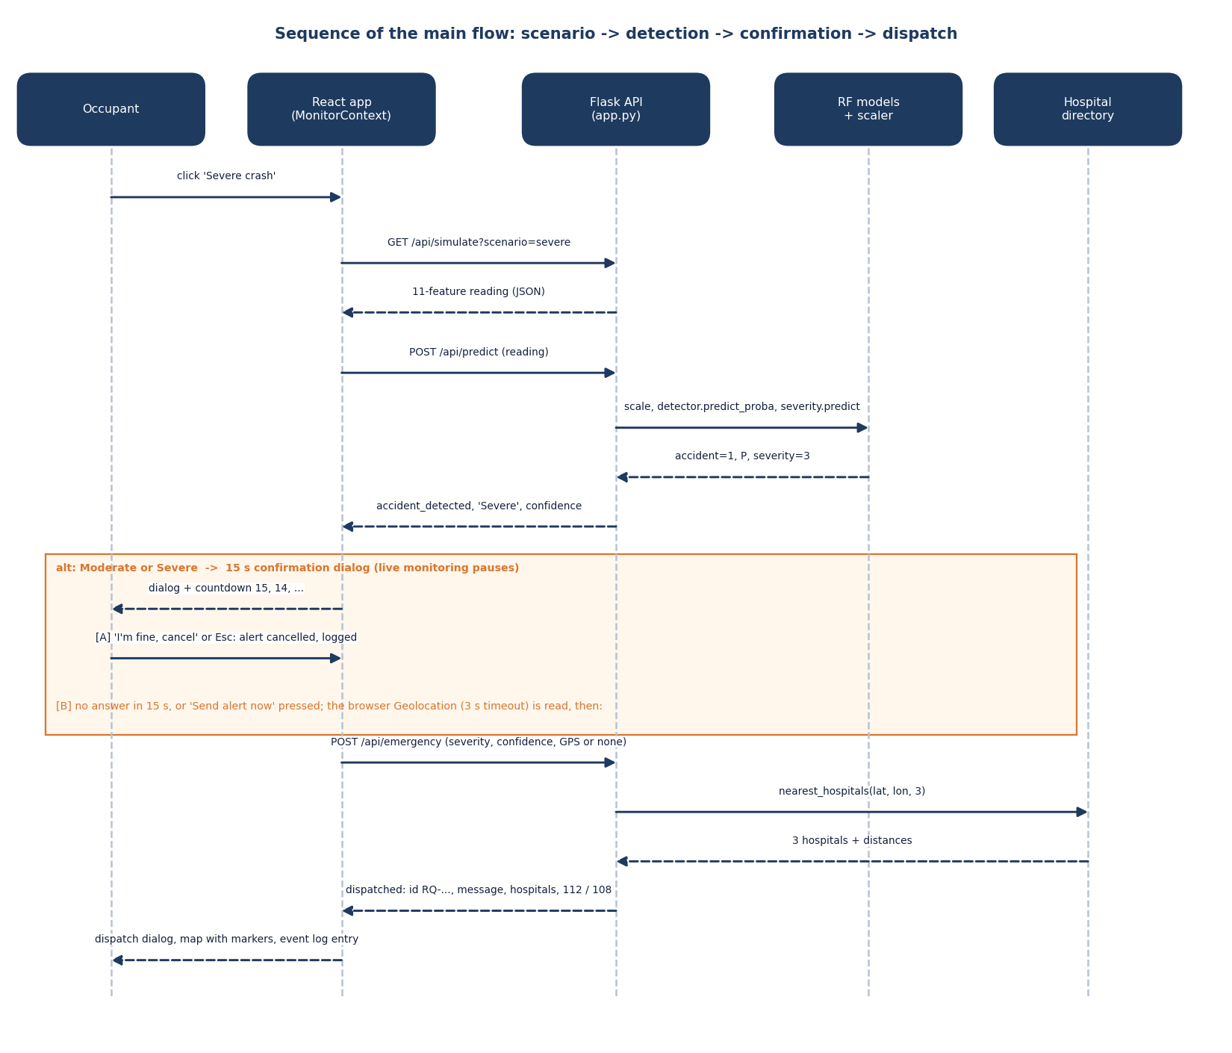
Figure 3: Sequence of the main flow: scenario, detection, confirmation and dispatch.
The sequence diagram shows the same flow as messages between the five parties. Two details are worth noting. First, the detector and the severity model are called inside one request, so the browser sees one consistent answer rather than two. Second, the location is read in the browser, not on the server: the server only receives numbers, and if the position is unavailable it substitutes a random point within about six kilometres of the default Hyderabad location, which keeps the demonstration working on a machine with no location service.

1.3 Data Flow Diagrams

1.3.1 Level 0 (context diagram)
At level 0 ResQAI is a single process with one human entity and two outside services. The occupant supplies credentials, a scenario or manual sensor values, and the cancel-or-send decision, and receives the detection result, the countdown, the dispatch message, the hospitals, the map and the event log. The Geolocation API returns the device coordinates and the tile server returns map images. The diagram also records what is not an entity: there is no phone supplying readings, no responder receiving the message and no hospital system; those three would be added in a deployment.
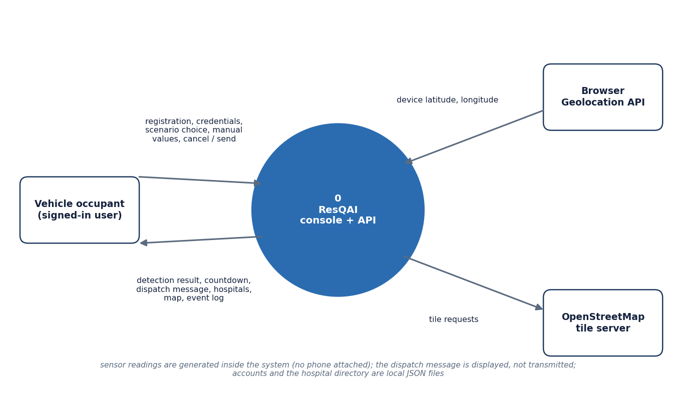
Figure 4: Context diagram (DFD level 0) of ResQAI with its user and the two outside services.

1.3.2 Level 1
Level 1 splits the system into six processes. Authentication (1.0) is the only process that touches the users file; it issues the signed token. Reading acquisition (2.0) produces the eleven-feature record either from the simulator or from the typed values. Detection and grading (3.0) reads the model pickles and returns the accident flag, the probability and the severity. Alert confirmation (4.0) is entirely client-side and is the human-in-the-loop step. Location and hospital ranking (5.0) reads the directory, and dispatch composition (6.0) builds the message. The three data stores are the users file (D1), the hospital directory (D2) and the model pickles (D3).
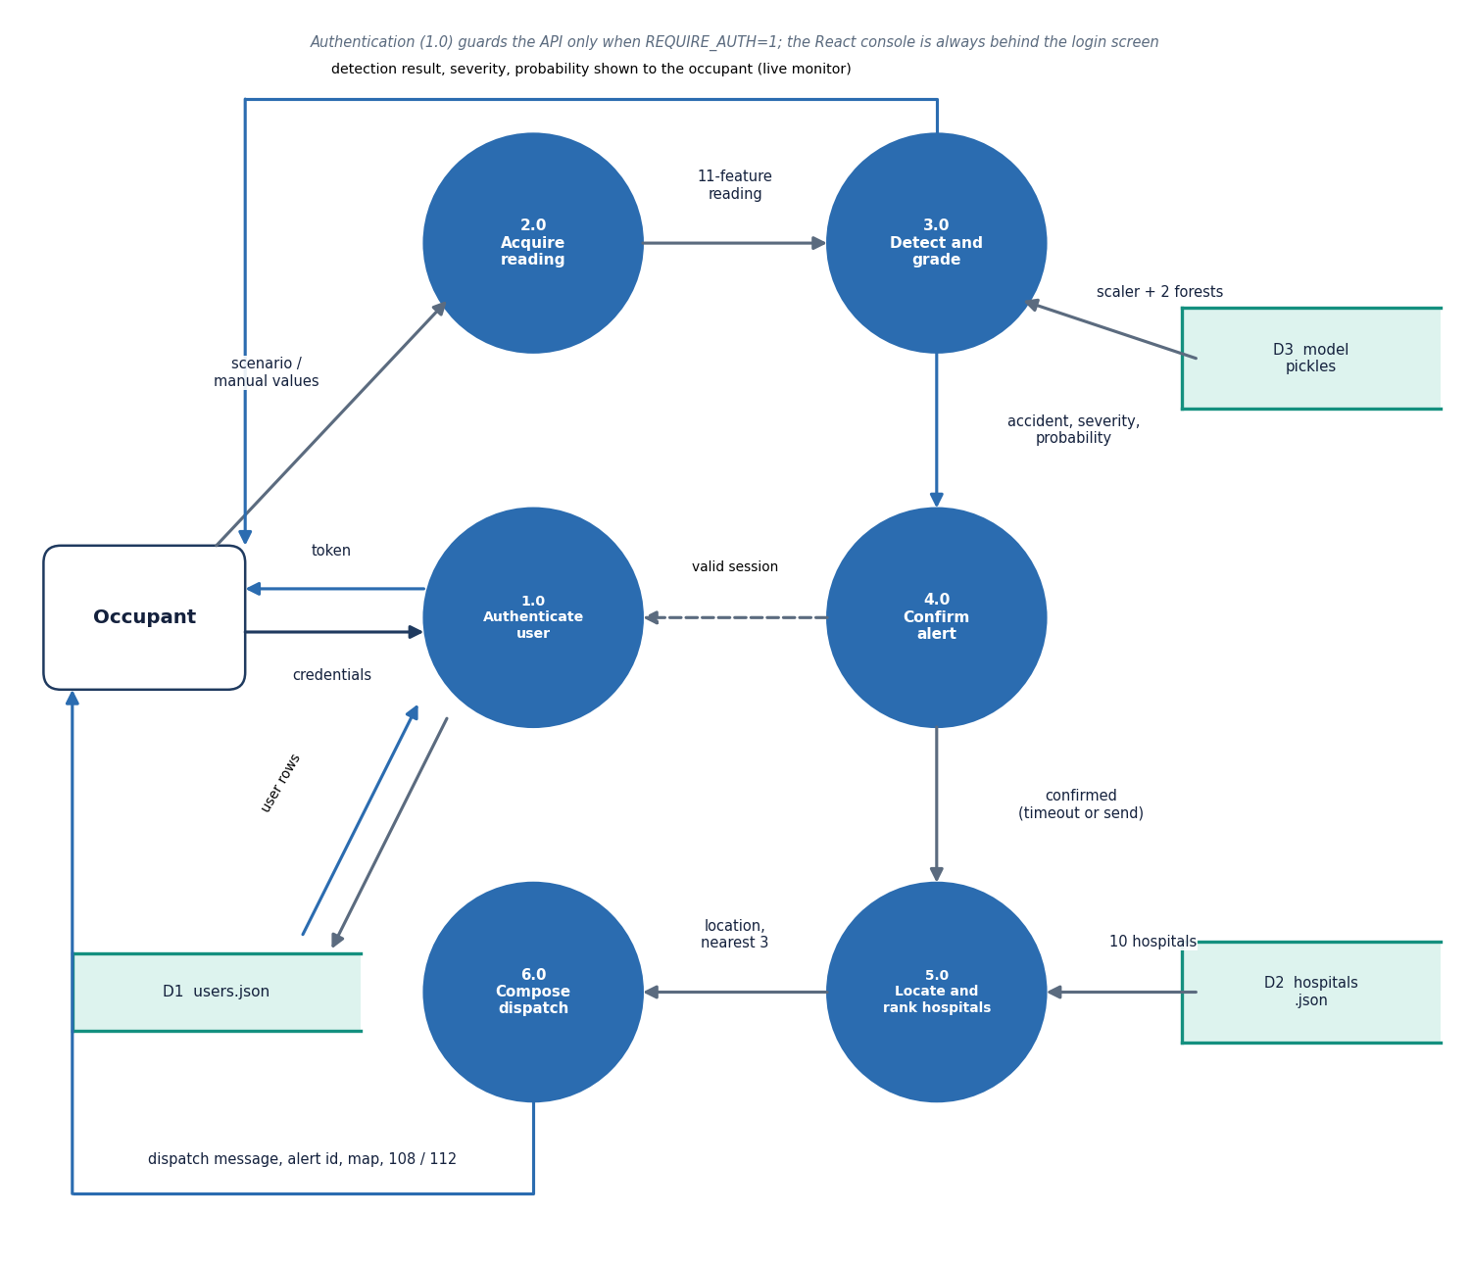
Figure 5: DFD level 1 of ResQAI: six processes and three data stores.

1.3.3 Level 2
Level 2 expands process 3.0, because it is where the machine learning happens and where the design makes its one non-obvious rule. The payload is completed with defaults (a missing acc_z becomes 9.81 m/s², a missing velocity field becomes zero) and the derived magnitudes are computed (3.1). The vector is scaled with the training mean and standard deviation (3.2). The detector (3.3) and the severity model (3.4) both receive the scaled vector; the gate (3.5) then forces the severity to None whenever the detector says no accident. Process 3.6, the rule-based fallback, is drawn dashed because it runs only when the model files cannot be loaded.
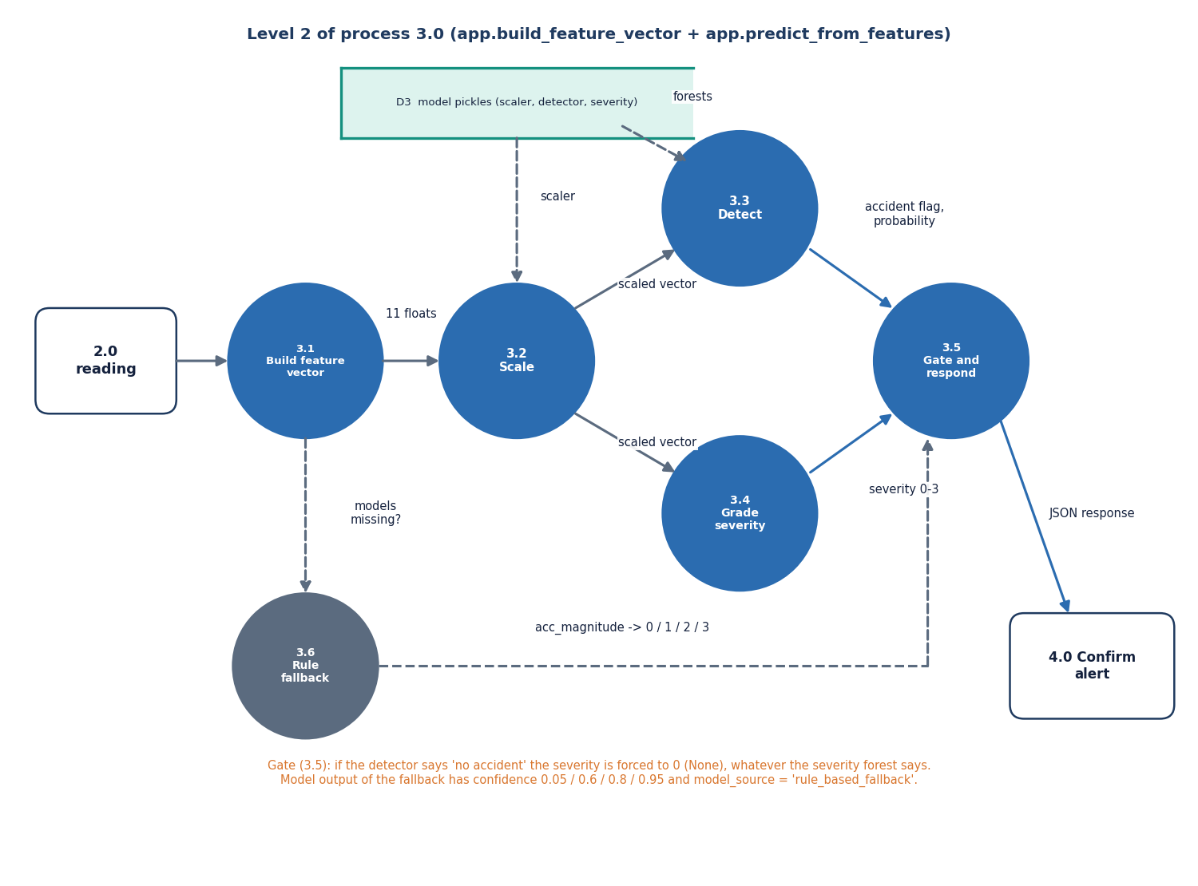
Figure 6: DFD level 2 of process 3.0: expansion of build_feature_vector and predict_from_features.

1.4 UML Diagrams

1.4.1 Class diagram
The backend is written as functions in two modules rather than as application classes, so the class diagram is a design-level view of the objects those functions pass around. SensorReading is the eleven-feature record built by build_feature_vector; Prediction is the response of /api/predict; EmergencyAlert is the response of /api/emergency. All three are transient and exist as JSON. RandomForestClassifier appears once in the diagram but twice at run time: the detector (200 trees, depth 10) and the severity model (250 trees, depth 12). StandardScaler is shared. HospitalDirectory wraps the ten-entry JSON file with the great-circle distance and the nearest-k selection. On the client, MonitorProvider is the state machine; AuthService and User describe auth.py and the accounts file.
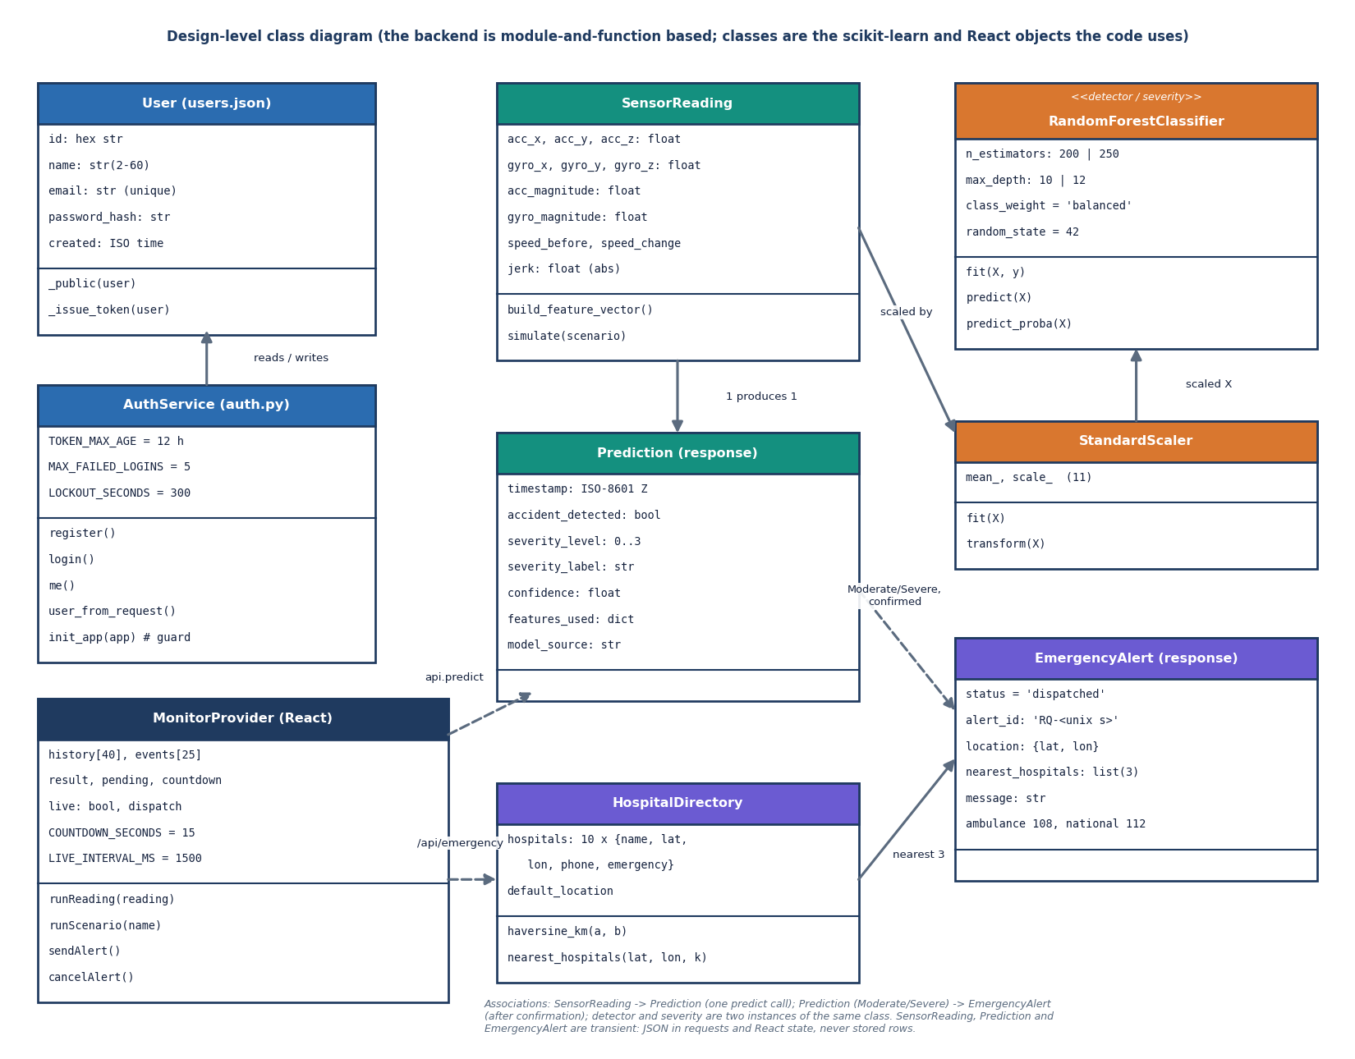
Figure 7: Design-level class diagram of ResQAI: data classes, the two scikit-learn model objects, the hospital directory and the React state provider.

1.4.2 Use-case diagram
The occupant is the only interactive actor. The developer actor covers activities that happen on the command line: retraining the models with train_models.py, switching the API guard on with REQUIRE_AUTH=1, and running the test and measurement scripts. The two external services support the location and map use cases. The table after the diagram expands the eight use cases.
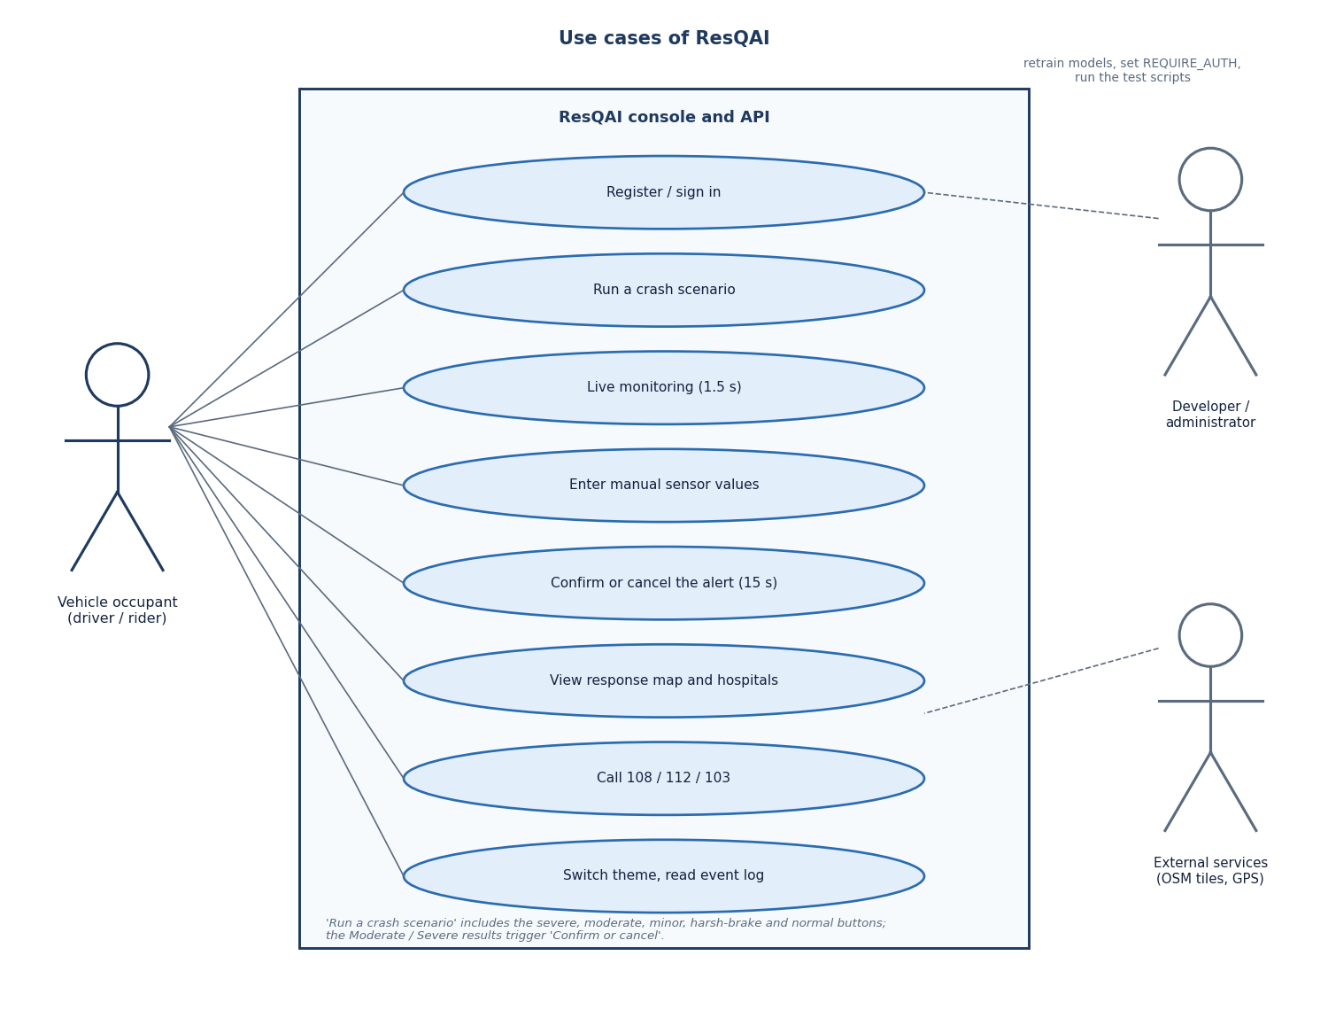
Figure 8: Use cases of ResQAI for the vehicle occupant, the developer and the external services.
Table 3: Use cases of the occupant
ID | Use case | Pre-condition | Main flow | Outcome
UC1 | Register / sign in | none | Enter name, e-mail, password (8 to 128 characters); receive a token | console unlocked; five wrong passwords lock the account for 5 minutes
UC2 | Run a scenario | signed in | Press Normal, Harsh brake, Minor, Moderate or Severe | result panel, trace point and log line; countdown for Moderate / Severe
UC3 | Live monitoring | signed in | Switch on; one random reading every 1.5 s | stops itself when a countdown opens or the API fails
UC4 | Manual override | signed in | Type seven values (client-side range checks), run detection | result for a hand-made reading; derived acc. magnitude shown before the run
UC5 | Confirm or cancel | a Moderate / Severe result | Cancel, press Escape, send now or let 15 s expire | alert cancelled and logged, or dispatched
UC6 | View response map | signed in | Open the Emergency response screen | hospital directory before an alert; accident and 3 nearest hospitals after it
UC7 | Call emergency numbers | none | Tap 108, 112 or 103 | the device dialler opens (tel: link)
UC8 | Theme and log | none | Toggle light / dark; read the last 25 events | preference kept in local storage

1.5 Data Design
ResQAI has no relational database, and the report does not draw one. The data design follows from what must survive a restart. Only three things must: the accounts, the hospital directory and the trained models. Everything produced while the console is in use, namely readings, predictions and alerts, is transient. This is an honest simplification for a demonstration and one of the first things a production version would change.
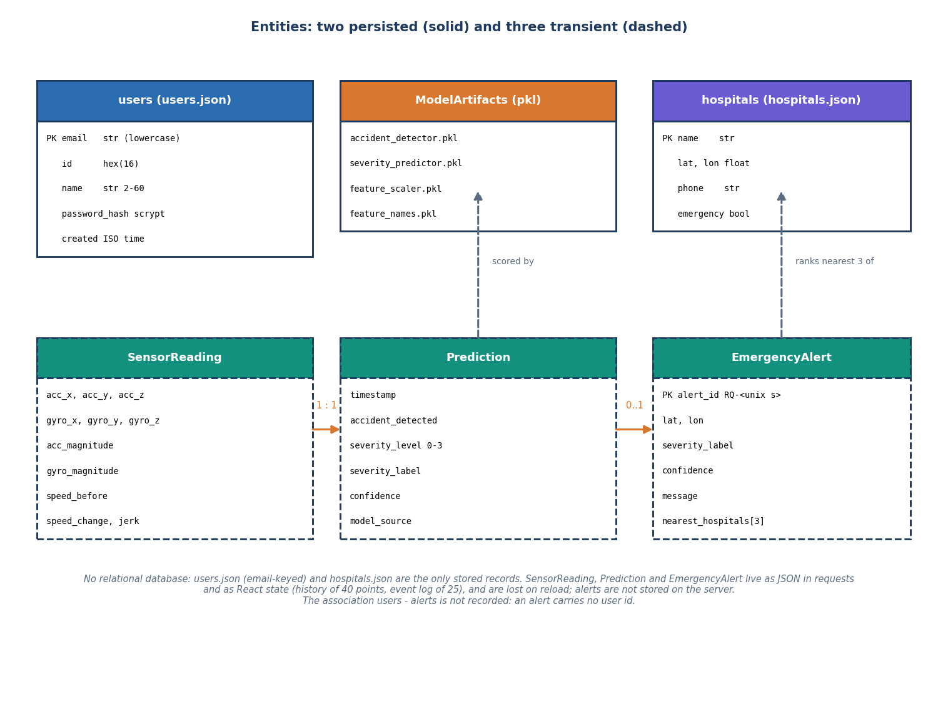
Figure 9: Entities of ResQAI: two persisted records, the model files, and three transient run-time entities.
Table 4: Persisted records
Store | Key | Fields | Size / count
data/users.json | lower-case e-mail | id (16 hex), name (2 to 60), email, password_hash (scrypt:32768:8:1), created (ISO time) | grows with sign-ups; written atomically through a temporary file and os.replace under a lock
data/hospitals.json | name | lat, lon, phone, emergency flag; plus default_location (Hyderabad, 17.3850, 78.4867) | 10 hospitals
models/accident_detector.pkl | - | RandomForest, 200 trees, depth 10 | 385.5 KB
models/severity_predictor.pkl | - | RandomForest, 250 trees, depth 12 | 2,608.2 KB
models/feature_scaler.pkl, feature_names.pkl | - | StandardScaler (11 means and scales); the ordered list of 11 feature names | 0.8 KB and 0.1 KB

The three transient entities are shown dashed in the figure. A reading is the JSON body of one request; a prediction is its response; an alert is the response of /api/emergency. The browser keeps the last 40 trace points and the last 25 log lines in React state, and the current dispatch, so a page reload empties them. Two consequences follow and are recorded as limitations: the server keeps no history of events, and an alert carries no user id, so alerts cannot be tied to an account. The failed-login counters used for the lockout are also only in memory and reset when the server restarts.
The reasons for the design are practical. A JSON file for ten hospitals is easier to read and edit than a table, and swapping it for a call to a hospital-search service changes one function. Accounts in a file are acceptable for a single-machine demonstration, and the write path is safe against a torn file because the new content is written to a temporary file and then renamed. A database such as SQLite or PostgreSQL, with tables for users, alerts and events and a foreign key from each alert to a user, is the obvious next step (Chapter 10).

1.6 Module Design
The delivered code is small and flat. The three Python modules of the product have about 553 non-blank lines, the React source about 3,377 lines of JSX, JavaScript and CSS, and the scripts written for testing and measurement about 922 lines. The table below lists each module with its responsibility and its main entry points.
Table 5: Modules and their responsibilities
Module | Responsibility | Main functions or components
app.py | REST API, helpers, model loading | build_feature_vector, predict_from_features, rule_based_fallback, haversine_km, nearest_hospitals, random_nearby_point; routes /, /api/predict, /api/simulate, /api/hospitals, /api/emergency, /api/health
auth.py | accounts and the optional API guard | register, login, me, status, user_from_request, init_app (the before_request guard); in-memory lockout table
train_models.py | synthetic data and training | make_event, generate_dataset, main (split, scale, fit, report, joblib.dump)
frontend/src/state/MonitorContext.jsx | client state machine | runReading, runScenario, live-monitoring interval, sendAlert, cancelAlert, countdown effects
frontend/src/lib/ | client infrastructure | api.js (fetch wrapper, token), auth.jsx (session, 401 handling), theme.jsx, format.js (scenarios, severity colours, emergency numbers), storage.js
frontend/src/pages/ | screens | Landing, Auth (login and register), Monitor, Manual, Response, NotFound
frontend/src/features/ | reusable parts | ResultPanel, SensorChart, EventLog, AlertOverlays (countdown and dispatch dialogs), MapView (Leaflet), ContactsCard, ApiError
scripts/ | verification | smoke_test.py, run_tests.py, measure_metrics.py, measure_api.py, capture_screens.py, capture_extra_screens.py
templates/, static/ | the original single-page dashboard | served at /; still works beside the React console

`app.py` is organised in three layers: loading (the models and the hospital file are read once, inside a try that falls back to the rule engine), pure helpers that can be tested without a server, and thin route functions that only read the request, call a helper and return JSON. The helper build_feature_vector is the single place where the payload is normalised, so the manual form, the simulator and a future phone client all pass through the same code. `auth.py` keeps the accounts file and the signing serializer private and exposes a blueprint; its init_app registers a before_request hook that, only when REQUIRE_AUTH is set, rejects any /api/ request except health and the auth routes unless a valid token is present. `MonitorContext.jsx` is the largest client module and the only one with logic that matters for safety: it decides when a countdown starts, stops live readings under an open dialog, cancels on Escape and calls the dispatch endpoint exactly once.

1.7 Algorithm Design
The core algorithm is the function predict_from_features and the client-side rule that follows it. The flowchart below shows it. In words: build the feature vector, check that the models are loaded, scale the vector, ask the detector for the class and the probability of an accident, ask the severity model for the grade, and set the grade to None if the detector said no. Only after the response reaches the browser does the confirmation rule apply: open the 15-second countdown when the grade is Moderate or Severe.
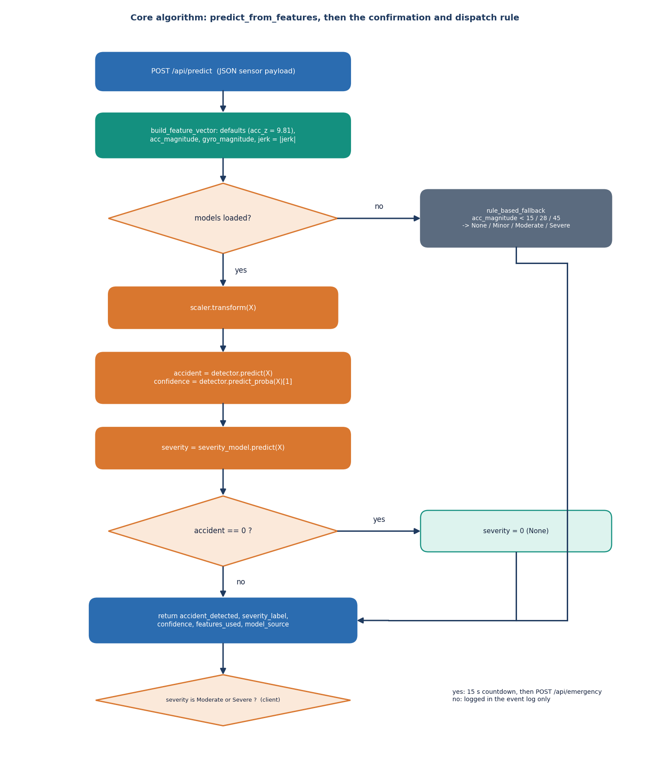
Figure 10: Flowchart of predict_from_features and the client-side confirmation rule.
The gate is deliberate. The severity forest is trained on all events with None as class 0, so it can also say None; the detector is trained on the binary label. Letting the detector override the severity means that the two models can never contradict each other in the response (an event reported as no accident always has severity None), and it gives one place to adjust the system's willingness to alert. On the 2,400 held-out events the gate changes nothing, because the severity model alone gives the same accuracy (99.958%); it matters when the two models would disagree, for example under noise.
The offline training pipeline is a separate algorithm, run once. It generates the data, splits it, fits the scaler on the training part only, trains the two forests with balanced class weights, prints the held-out accuracy and report, and writes the four pickles.
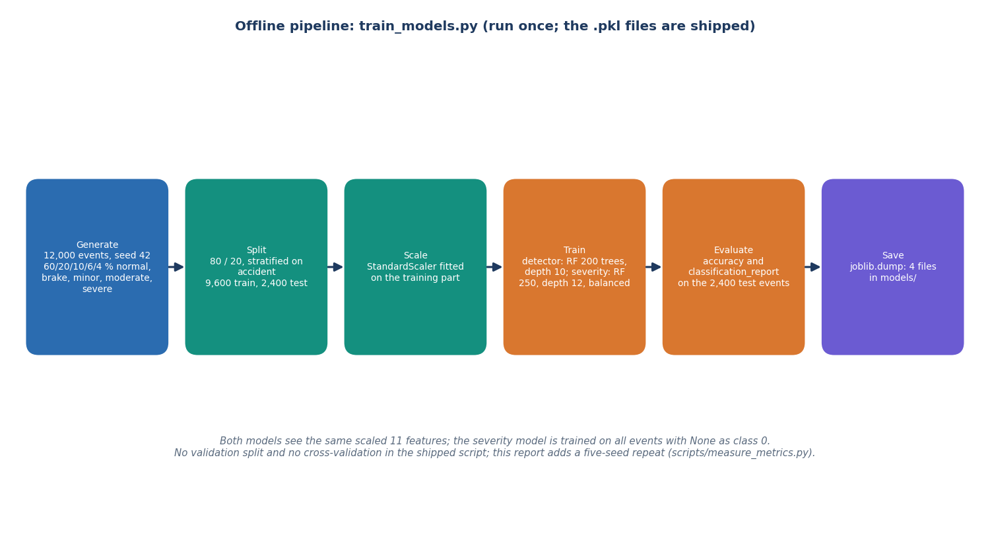
Figure 11: Offline pipeline of train_models.py: generate, split, scale, train, evaluate, save.

1.8 User Interface Design
The interface is a React console in a neo-brutalist visual style: heavy outlines, flat colour blocks, a lime accent and a coral accent reserved for danger, with a light and a dark theme that is remembered between visits. Colour is never the only carrier of meaning: every severity is also a text badge, the result headline says No accident or Accident detected, and the countdown is a large numeral with a progress bar. The countdown dialog is a real dialog with a focus-first I'm fine, cancel button, a polite live-region announcement of the remaining seconds, and an Escape-to-cancel rule, so keyboard and screen-reader users can answer in time.
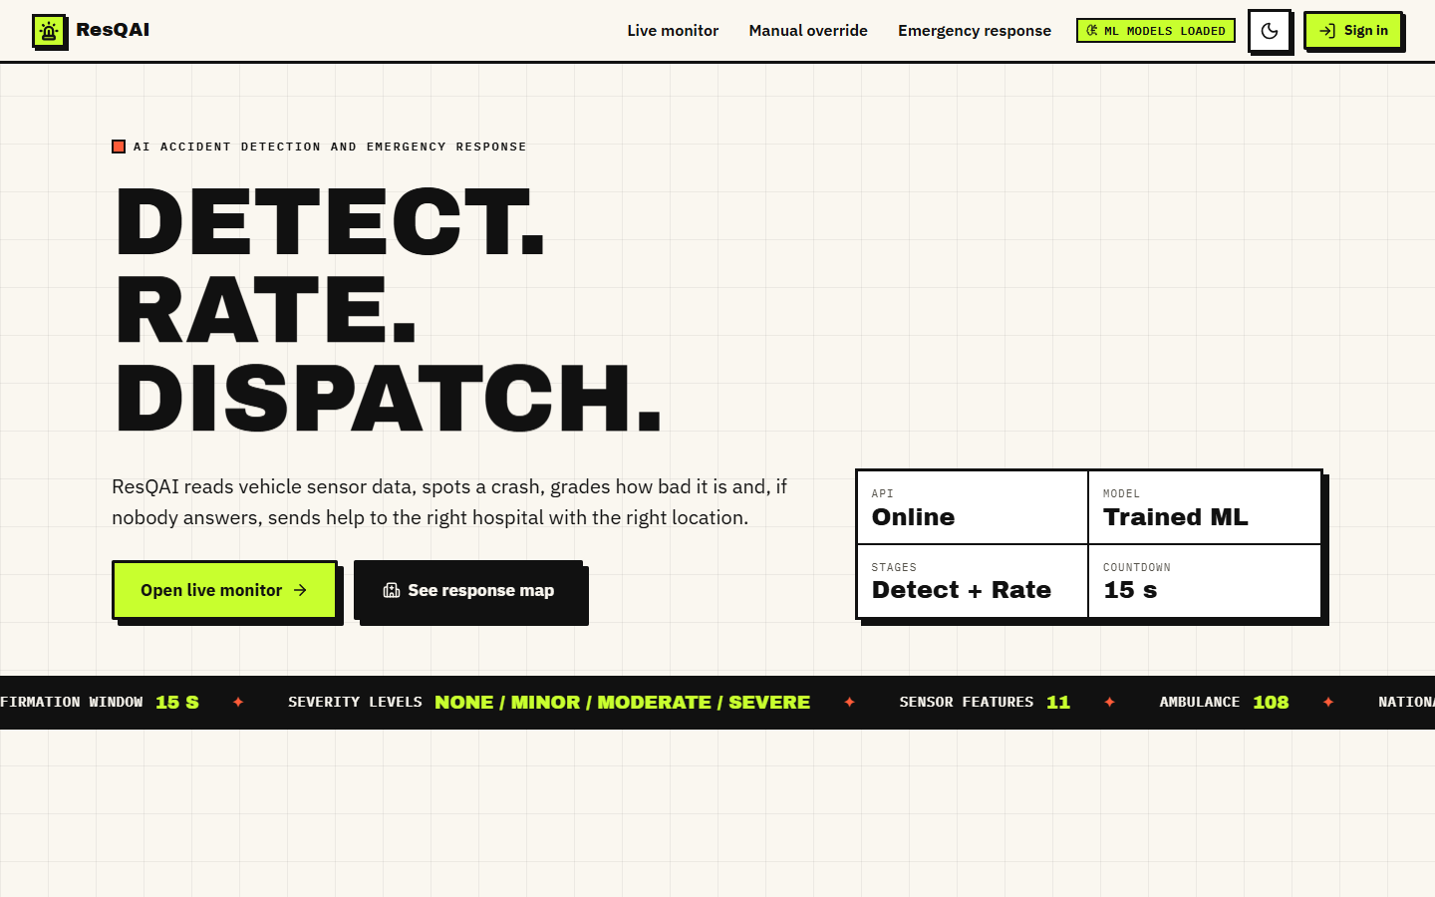  Figure 12: Landing page, light theme. | 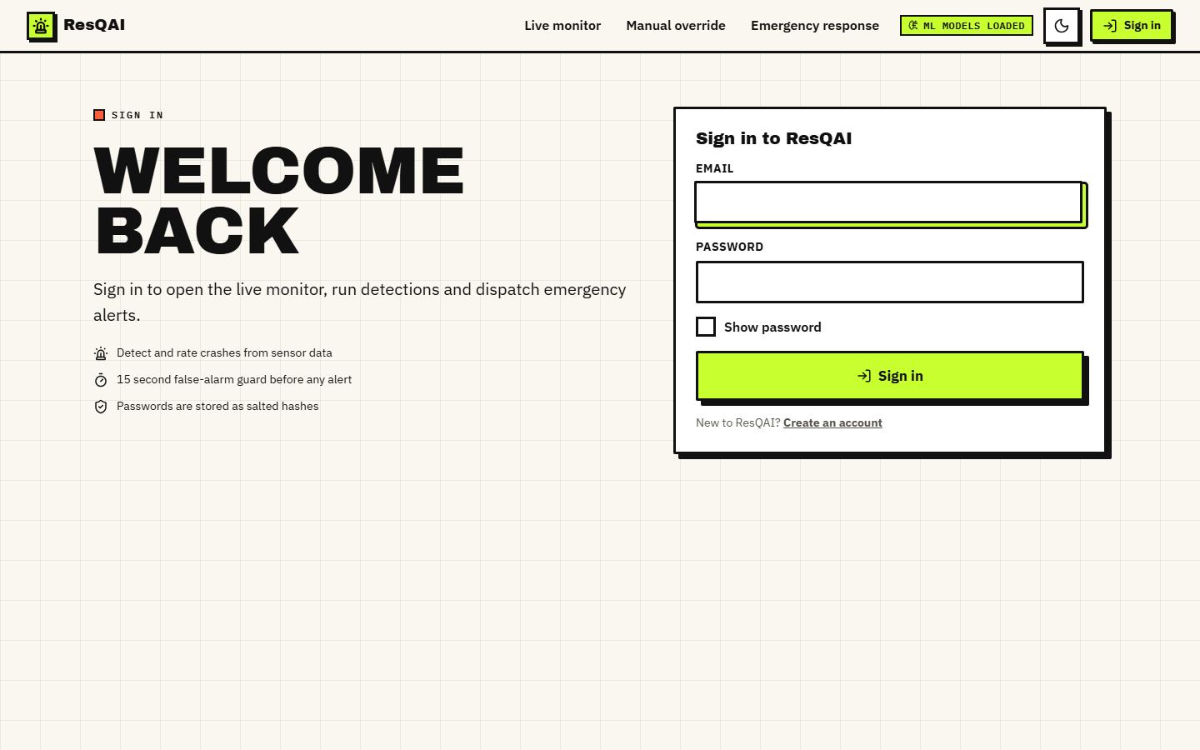  Figure 13: Sign-in form: the console is locked until an account signs in.

The landing page explains the pipeline in five steps (Five steps, no hand-offs) and links to sign-in. The three console screens sit behind the login: a signed-out visitor who opens /monitor is redirected to /login and returned to the page afterwards. Navigation is a left rail on wide screens; below 1,024 pixels the style sheet switches to a bottom bar (not captured as a screenshot in this report).
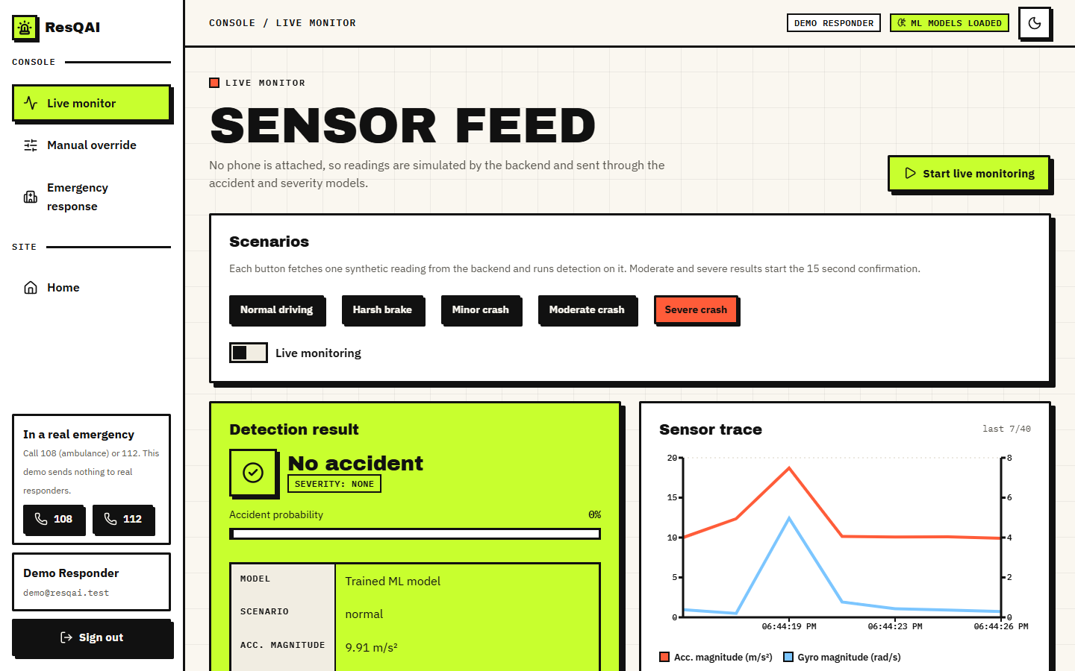  Figure 14: Live monitor: scenario buttons, live switch, detection result and the sensor trace. | 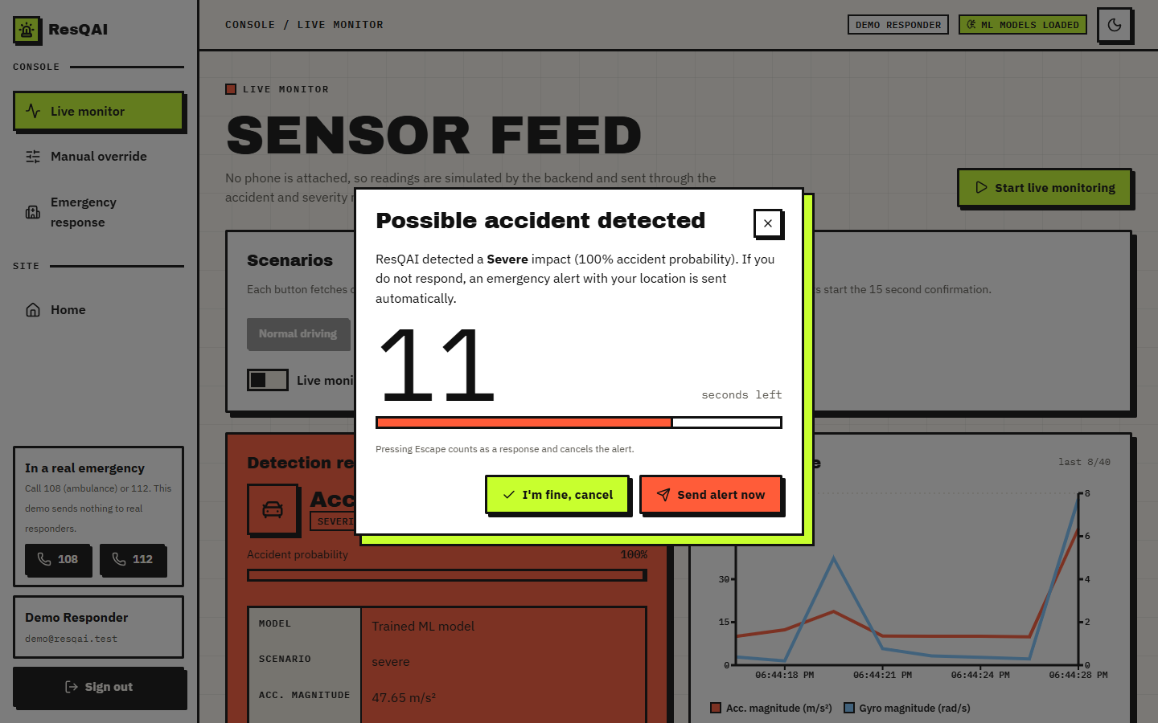  Figure 15: Confirmation dialog for a Severe result with 11 seconds left.

The Live monitor has three zones: the scenario buttons and the live-monitoring switch; the detection result (headline, severity badge, accident probability bar and a key-value table of the features used); and the sensor trace, a two-axis line chart of acceleration magnitude (m/s²) and gyroscope magnitude (rad/s) over the last 40 readings, followed by the event log. The Manual override screen has seven fields (three accelerations, gyroscope magnitude, speed before, speed change, jerk) with range checks in the browser, a live display of the derived acceleration magnitude, a Load simulated sample button and Reset.
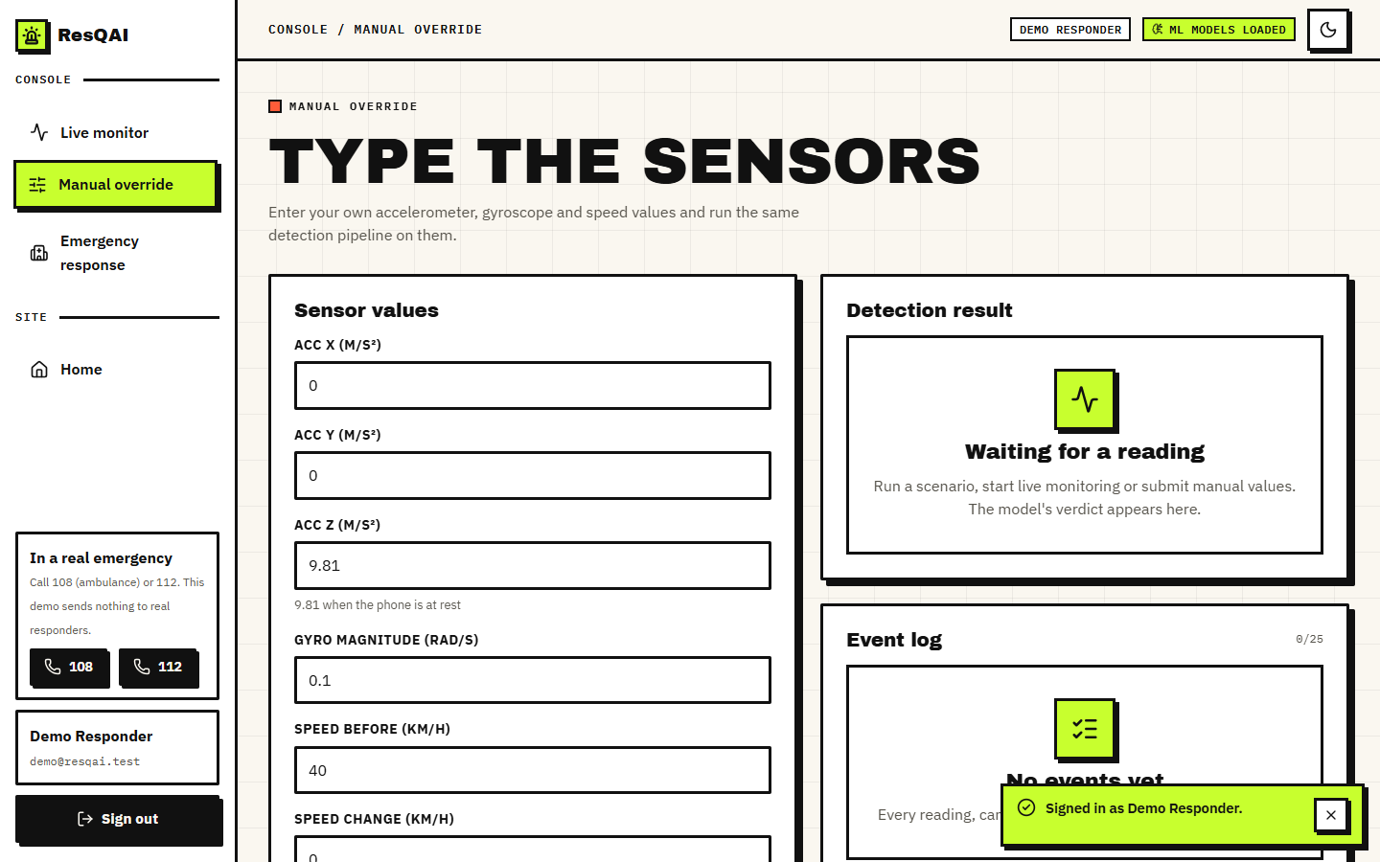  Figure 16: Manual override: seven inputs and the derived acceleration magnitude. | 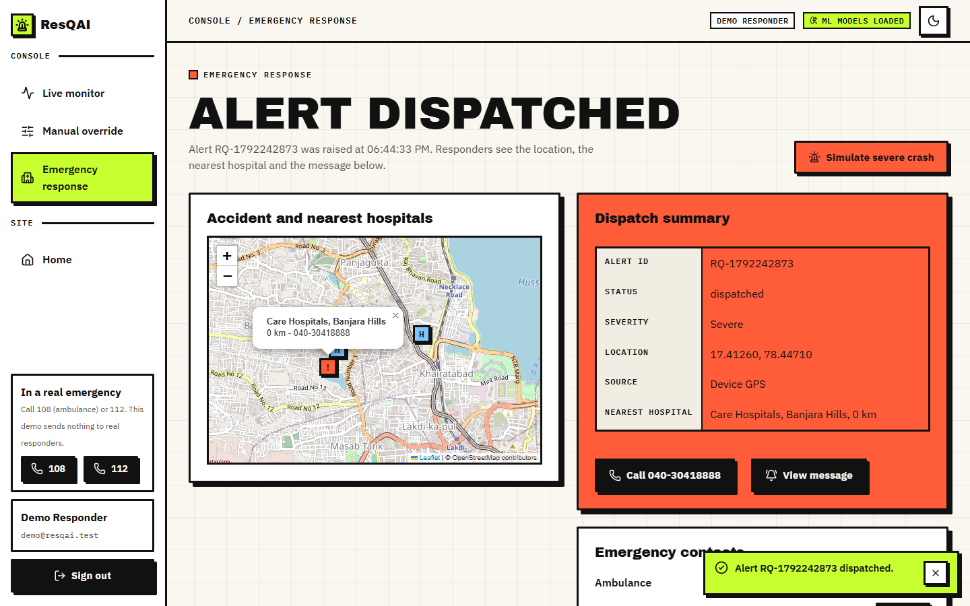  Figure 17: Emergency response after a dispatch: map, dispatch summary and nearest hospital.

The Emergency response screen shows the hospital directory around the default area before any alert, and after a dispatch it plots the accident position and the three nearest hospitals on an OpenStreetMap layer, with a summary table (alert id, status, severity, location, source, nearest hospital), a Call button for the nearest hospital, a View message dialog with a copy button, and the three emergency numbers. A banner inside the dispatch dialog says that the message is drafted but not sent.

1.9 Design Decisions and Trade-offs
Table 6: Main design decisions
Decision | Alternative | Reason for the choice | Cost
Two random forests (detect, grade) | one 4-class model; a neural network | forests need no feature engineering beyond magnitudes, train in seconds on a CPU, give a probability and have importance scores [21] | cannot extrapolate; ~2.6 MB for the severity model
Detector gates the severity | trust the severity model alone | the response can never say no accident with a severity other than None | one more rule to explain
Confirmation window of 15 s, client-side | alert at once; longer window | gives a conscious occupant time to stop a false alarm; short enough for a real emergency | an unconscious occupant delays the alert by 15 s
Only Moderate / Severe start the countdown | also Minor | Minor crashes would interrupt the driver; they are logged | a Minor crash with a hurt occupant is not escalated
Simulated sensors served by the backend | a real phone app | no hardware or recordings were available; the simulator mirrors the training generator so the demo is repeatable | results say nothing about real sensors
JSON files instead of a database | SQLite / PostgreSQL | ten hospitals and a handful of accounts; zero set-up | no event history, no alerts per user, no concurrency control beyond one lock
Haversine ranking of a 10-hospital directory | routing distance; a places API | closed form, no network [25]; adequate for a demo | straight-line distance ignores roads, traffic and capacity
Signed tokens, optional guard | mandatory guard; server sessions | keeps the original dashboard working; tokens are stateless and expire in 12 h | the guard is off by default, so a default install exposes the API to the local network
Flask development server | gunicorn / waitress | single command start-up on Windows | not a production server; debug=True must be off outside a demonstration

1.10 Quality Attributes
Performance. On loopback, /api/predict takes a mean of 26.2 ms (95th percentile 37.8 ms) and the three-call alert path takes a mean of 56.4 ms; the model call alone takes 14.0 ms in process. The 15-second confirmation window therefore dominates the time to an alert by more than two orders of magnitude, which is the intended trade. The numbers were measured with the Flask development server on a machine that was short of memory (Chapter 7).
Reliability. The application starts and answers without the model files, using the rule-based fallback; the front end shows an explicit Cannot reach the ResQAI API banner with a retry button instead of a blank screen, stops live monitoring on the first failure and logs the error. Security. Passwords are stored as scrypt hashes, tokens are signed and expire after 12 hours, repeated failures lock an account, and the guard can be switched on for the whole API; Chapter 6 lists the validation gaps that the tests found. Usability. One-click scenarios, an Escape key that answers the countdown, tap-to-call links and light and dark themes keep the console usable under stress. Maintainability. The helpers in app.py are pure functions, the front end is split into pages, features and a small UI kit, and every number in this report can be regenerated with three scripts.

2. IMPLEMENTATION

2.1 Application Architecture and Implementation
Back end. app.py creates the Flask application, registers the auth blueprint, loads the four pickles and hospitals.json once at import time inside a try block, and defines the routes. The server is started with python app.py, which runs the Werkzeug development server with debug=True on the port in the PORT variable (8302 under run.bat); debug=True also starts a reloader process. Because the models are module-level objects, every request in the process shares them, and scikit-learn's predict calls are read-only, so no lock is needed around inference. The only shared mutable state is the accounts file, guarded by a threading.Lock, and the in-memory failed-login table.
Front end. The React source (about 3,377 lines) is a single-page application built with Vite. Pages are loaded lazily, so the map library, which is the heaviest dependency, is fetched only when the Emergency response screen is opened. The production build succeeds in about 3.6 seconds; its largest chunks are the line-trace chart (353 kB, 103 kB gzipped), the UI kit (346 kB, 121 kB gzipped), the entry chunk (219 kB, 70 kB gzipped) and the map view (150 kB, 44 kB gzipped). State lives in MonitorContext, which is mounted above the routes, so a countdown survives navigation between screens, and is remounted with a new key when the user signs in or out, so one user's readings and alerts never show for the next. Authentication state lives in lib/auth.jsx; a 401 response on any protected call signs the user out through a callback registered with api.js.
Key implementation techniques. (1) One request in flight: live monitoring uses a setInterval plus an in-flight flag, so a slow response never causes two overlapping predictions. (2) Single pending alert: a ref, pendingRef, is set when a Moderate or Severe result arrives and cleared on cancel or send, so a second severe result cannot open a second countdown and the alert is sent exactly once. (3) Countdown: an effect decrements a counter every second while an alert is pending, and a second effect calls sendAlert when the counter reaches zero. (4) Location: navigator.geolocation.getCurrentPosition with a three-second timeout, falling back to no coordinates, in which case the server chooses a point. (5) Graceful failure: a failed request sets an error state with a retry button and logs a Severe-toned line, instead of leaving the interface blank.

2.2 API Design
The API is JSON over HTTP with no versioning prefix. Responses use ordinary status codes; the auth routes return {error, field} for validation failures so that the form can mark the offending field.
Table 7: Endpoints
Method and path | Request | Response | Notes
GET /api/health | - | {status, models_loaded} | public, also when the guard is on
GET /api/simulate?scenario= | normal, brake, minor, moderate, severe or random | 11 features + scenario | unknown name falls back to a random scenario (weights 65 / 18 / 9 / 5 / 3 %)
POST /api/predict | JSON of the nine raw channels (magnitudes optional) | accident_detected, severity_level, severity_label, confidence, features_used, model_source, timestamp | empty body is a calm reading
GET /api/hospitals?lat&lon&k= | position, count | origin, hospitals[] with distance_km | default k = 3; the UI asks for 5
POST /api/emergency | severity_label, confidence, optional lat, lon | status, alert_id, location, nearest_hospitals[3], message, national_emergency_number 112, ambulance_number 108 | random point near the default area when no position is sent
POST /api/auth/register | name, email, password | token, user (201) | 400 with field, 409 for a duplicate
POST /api/auth/login | email, password | token, user | 401 wrong, 429 after 5 failures
GET /api/auth/me, /status | Bearer token / none | user / {auth_required} | 401 for an invalid or expired token

A real exchange, produced by calling the application with a hand-made moderate-crash reading, shows the shapes:
POST /api/predict
{"acc_x": 30.0, "acc_y": 22.0, "acc_z": 9.81, "gyro_x": 2.1, "gyro_y": -1.4, "gyro_z": 3.0,
"speed_before": 62, "speed_change": -48, "jerk": 36}

200 {"accident_detected": true, "severity_level": 2, "severity_label": "Moderate", "confidence": 1.0,
"model_source": "trained_ml_model", "timestamp": "2026-10-25T02:54:27Z",
"features_used": {"acc_magnitude": 38.47, "gyro_magnitude": 3.92, "jerk": 36.0, ...}}

POST /api/emergency {"severity_label": "Moderate", "confidence": 1.0, "lat": 17.4126, "lon": 78.4471}

200 {"status": "dispatched", "alert_id": "RQ-1792896867", "location": {"lat": 17.4126, "lon": 78.4471},
"nearest_hospitals": [{"name": "Care Hospitals, Banjara Hills", "distance_km": 0.0, ...},
{"name": "Rainbow Children's Hospital, Banjara Hills", "distance_km": 0.27, ...},
{"name": "Yashoda Hospitals, Somajiguda", "distance_km": 1.34, ...}],
"message": "ResQAI EMERGENCY ALERT / Severity: Moderate (confidence 100%) / Location: 17.41260, 78.44710 /
Google Maps: https://www.google.com/maps?q=17.41260,78.44710 /
Nearest hospital: Care Hospitals, Banjara Hills (0.0 km away, 040-30418888) /
No response received from occupant. Please dispatch assistance.",
"national_emergency_number": "112", "ambulance_number": "108"}

The example also shows a limitation of the directory: it has an emergency flag for every entry and no information on specialty, so a children's hospital is ranked as the second-nearest destination for an adult crash. The confidence field is the probability of the accident class, not of the severity grade, and the dispatch message presents it as the confidence of the grade; that wording would need to change in a deployment.

2.3 Security and Error Handling
Accounts. Registration accepts a name of 2 to 60 characters, an e-mail address matching a simple pattern (at most 120 characters) and a password of 8 to 128 characters. E-mail addresses are lower-cased, so duplicates are detected case-insensitively (HTTP 409). Passwords are hashed with werkzeug's generate_password_hash, whose current default is scrypt with parameters 32768, 8, 1 (the stored prefix is scrypt:32768:8:1) [27]; the plain password is never stored or returned. The accounts file is written to a temporary file and renamed, under a lock, so a crash cannot leave half a file.
Tokens and lockout. A successful login returns a token produced by itsdangerous.URLSafeTimedSerializer with the salt resqai-auth; it holds only the user id, is signed with a secret from the SECRET_KEY variable or a random 32-byte key generated once into data/.secret, and expires after 12 hours. Five failed logins for an e-mail address within five minutes make further attempts return HTTP 429 for the remainder of the window, even with the correct password; the counters are in memory, so a restart clears them and they are keyed by e-mail only, not by client address.
The API guard. REQUIRE_AUTH=1 makes a before_request hook reject every /api/ request, except /api/health and /api/auth/*, that has no valid Bearer token, and lets OPTIONS requests through. The default is 0 so the original dashboard keeps working. This means a default installation exposes the prediction and emergency endpoints to anyone who can reach the port, and app.run(host='0.0.0.0') makes that the whole local network; for any shared use the guard should be on and the server bound to the loopback address.
What the tests found. The 55 checks of scripts/run_tests.py (47 pass) include 18 security checks, all of which pass: unauthenticated calls refused, altered and non-Bearer tokens refused, no hash in any response, short and long inputs rejected, duplicate e-mail, lockout, stored hash format, ignored files and OPTIONS. The eight failures are all input-validation gaps in app.py and are listed below. None gives access to data, but several return HTTP 500 where a 4xx is correct, and two (the free-text severity label and the unchecked coordinates) let a client shape the dispatch message.
Table 8: Validation gaps found by the edge-case tests (not fixed; product code was left untouched)
Input | Observed | Expected | Effect
non-numeric field in /api/predict, e.g. acc_x: "abc" | HTTP 500 | 400 | float() raises; unhandled
JSON array as the body of /api/predict | HTTP 500 | 400 | payload.get on a list
non-numeric lat in /api/hospitals | HTTP 500 | 400 | unhandled ValueError
k=-1 in /api/hospitals | 200 with 9 of 10 hospitals | empty or 400 | Python slice [:-1]
lat=999, lon=999 | 200, distances computed | 400 | no range check
non-numeric confidence in /api/emergency | HTTP 500 | 400 | unhandled float()
free-text severity_label (e.g. with a line break) | copied into the dispatch message | one of the four labels | message can be shaped by the client
two alerts in the same second | same alert_id (RQ-<unix seconds>) | unique ids | ids are not unique

The remaining twelve edge-case checks pass: malformed JSON gives 400; an empty object, NaN, absurdly large values and a negative speed are answered without a crash; GET on a POST route gives 405; an unknown scenario falls back; k=0 returns an empty list and k=1000 is capped at the ten entries. Error handling in the browser: a network failure or a 5xx without a body becomes the banner Cannot reach the ResQAI API with a retry button, a 401 on a protected call signs the user out, and the dispatch step shows a toast with the reason if /api/emergency fails, leaving the alert unsent but visible in the log. A weakness is that a failed dispatch is not retried automatically.

2.4 Installation and Execution
The application targets Windows with Python 3.10 or later and Node.js 18 or later. First time: run setup.bat, which creates venv, installs requirements.txt (Flask, scikit-learn, joblib, NumPy, pandas), runs npm install in frontend/ and copies .env.example to .env. Every time: run run.bat, which checks that ports 8302 and 5302 are free, starts the API and the Vite server in two windows and opens http://localhost:5302; stop.bat ends both. The ports and REQUIRE_AUTH can be changed in .env. To retrain the models, run python train_models.py once; it overwrites the four files in models/.
Checks. With the application running, python scripts/smoke_test.py runs 33 checks through the Vite proxy (33 pass); python scripts/run_tests.py runs the unit, edge-case and security checks (it needs a second backend started with REQUIRE_AUTH=1 on port 8399); python scripts/measure_metrics.py and python scripts/measure_api.py regenerate the metrics and the latency files in experiments/resqai_eval/; python scripts/capture_screens.py and python scripts/capture_extra_screens.py capture the screens with Playwright. On the first run an account must be created on the Create an account screen; the documentation scripts use the demo account demo@resqai.test.
Practical notes found while running the project. The venv folder is not shipped, so setup.bat installs the newest scikit-learn, which may differ from the 1.9.0 that wrote the pickles; the Flask reloader starts a second Python process, which doubles memory use on a small machine; and localhost can resolve to the IPv6 address, so API timing scripts should use 127.0.0.1. Appendix B repeats the installation steps as a user guide.

3. KEY CODE WALK-THROUGHS
This part reads the code that carries the main flow, quoting short excerpts from the project files exactly as they stand.

3.1 Building the feature vector (app.py)
A payload from the browser may omit fields, so the function gives each input a default, derives the two magnitudes if they were not supplied, takes the absolute value of the jerk, and returns the values in the order in which the models were trained.
def build_feature_vector(payload):
"""Turn an incoming sensor JSON payload into the ordered feature vector
expected by the models, deriving magnitudes/jerk if not supplied."""
acc_x = float(payload.get("acc_x", 0))
acc_y = float(payload.get("acc_y", 0))
acc_z = float(payload.get("acc_z", 9.81))
gyro_x = float(payload.get("gyro_x", 0))
gyro_y = float(payload.get("gyro_y", 0))
gyro_z = float(payload.get("gyro_z", 0))
speed_before = float(payload.get("speed_before", 0))
speed_change = float(payload.get("speed_change", 0))
jerk = float(payload.get("jerk", 0))

acc_magnitude = payload.get("acc_magnitude")
if acc_magnitude is None:
acc_magnitude = math.sqrt(acc_x ** 2 + acc_y ** 2 + acc_z ** 2)

gyro_magnitude = payload.get("gyro_magnitude")
if gyro_magnitude is None:
gyro_magnitude = math.sqrt(gyro_x ** 2 + gyro_y ** 2 + gyro_z ** 2)

feature_map = {
"acc_x": acc_x, "acc_y": acc_y, "acc_z": acc_z,
"acc_magnitude": acc_magnitude,
"gyro_x": gyro_x, "gyro_y": gyro_y, "gyro_z": gyro_z,
"gyro_magnitude": gyro_magnitude,
"speed_before": speed_before, "speed_change": speed_change,
"jerk": abs(jerk),
}
vector = [feature_map[name] for name in FEATURE_NAMES]
return np.array(vector).reshape(1, -1), feature_map

Two details matter. The default for acc_z is 9.81 m/s2 (one g), so an empty payload describes a stationary phone; and the vector is built from a dictionary indexed by FEATURE_NAMES, which are loaded from the same pickle as the models, so a change of feature order in training cannot silently misalign the columns.

3.2 Detection, severity and the gate (app.py)
This is the core of the system. When the models are loaded the vector is scaled, the detector gives the class and the probability of an accident, and the severity model gives the grade; if the detector says no accident the grade is forced to 0. Without the models the three thresholds of the fallback decide.
def predict_from_features(feature_map, X):
if MODELS_LOADED:
X_scaled = scaler.transform(X)
accident_pred = int(accident_model.predict(X_scaled)[0])
accident_proba = float(accident_model.predict_proba(X_scaled)[0][1])
severity_pred = int(severity_model.predict(X_scaled)[0])
# if the accident detector disagrees with "no accident" severity, trust
# the stronger signal (max of the two) for the alerting logic
if accident_pred == 0:
severity_pred = 0
return accident_pred, severity_pred, accident_proba
return rule_based_fallback(feature_map)

def rule_based_fallback(feature_map):
"""Simple threshold-based fallback used only if trained models are
unavailable, so the app always returns a sensible response."""
mag = feature_map["acc_magnitude"]
if mag < 15:
return 0, 0, 0.05
if mag < 28:
return 1, 1, 0.6
if mag < 45:
return 1, 2, 0.8
return 1, 3, 0.95

The comment in the source calls the gate 'trust the stronger signal'; what it does is to let the detector override the severity model. The reverse override is absent: a detector 'yes' with a severity of None is possible in principle (the severity forest could say None for an event the detector accepts) and would be returned as an accident of severity None, which the interface would show as an accident of severity None. On the 2,400 test events it never happens, but the code does not prevent it.

3.3 Distance and the nearest hospitals (app.py)
def haversine_km(lat1, lon1, lat2, lon2):
"""Great-circle distance between two lat/lon points, in kilometres."""
R = 6371.0
p1, p2 = math.radians(lat1), math.radians(lat2)
dphi = math.radians(lat2 - lat1)
dlambda = math.radians(lon2 - lon1)
a = math.sin(dphi / 2) ** 2 + math.cos(p1) * math.cos(p2) * math.sin(dlambda / 2) ** 2
return 2 * R * math.asin(math.sqrt(a))

def nearest_hospitals(lat, lon, k=3):
hospitals = HOSPITAL_DATA["hospitals"]
scored = []
for h in hospitals:
d = haversine_km(lat, lon, h["lat"], h["lon"])
scored.append({**h, "distance_km": round(d, 2)})
scored.sort(key=lambda h: h["distance_km"])
return scored[:k]

The haversine formula [25] gives the great-circle distance on a sphere of radius 6,371 km; for the few kilometres involved in a city the error against a road route is far larger than the error of the formula. The function ranks all ten hospitals on the distance rounded to two decimals and returns the first k; the rounding is why two hospitals a few metres apart can swap places, and why the unit test compares distances and not names. The route does not validate k, which is why k = -1 returns nine hospitals (Chapter 7).

3.4 Composing the dispatch message (app.py)
message = (
f"ResQAI EMERGENCY ALERT\n"
f"Severity: {severity_label} (confidence {round(float(confidence) * 100)}%)\n"
f"Location: {lat:.5f}, {lon:.5f}\n"
f"Google Maps: https://www.google.com/maps?q={lat:.5f},{lon:.5f}\n"
)
if nearest:
message += (
f"Nearest hospital: {nearest['name']} "
f"({nearest['distance_km']} km away, {nearest['phone']})\n"
)
message += "No response received from occupant. Please dispatch assistance."

The message is built with an f-string from the severity label and the confidence supplied by the client, the coordinates and the nearest hospital. The label is not validated, which is one of the eight findings; the alert id is the Unix time in seconds, which is the reason two alerts in one second collide.

3.5 The client-side confirmation rule (MonitorContext.jsx)
The browser, not the server, decides when to ask the occupant. After each prediction the context checks the grade; for Moderate and Severe it stores the result as pending, resets the countdown to 15 and stops live monitoring so that new readings do not pile up under an open question.
if ((r.severity_label === 'Moderate' || r.severity_label === 'Severe') && !pendingRef.current) {
pendingRef.current = r
setPending(r)
setCountdown(COUNTDOWN_SECONDS)
// Do not stream new readings under an open confirmation; the user restarts live monitoring afterwards.
if (liveRef.current) logEvent('Live monitoring paused while the alert awaits confirmation.')
setLive(false)

A one-second timer then decrements the countdown, and when it reaches zero the alert is sent exactly as if the occupant had pressed the button.
// Countdown ticks while an alert is pending; auto-sends at zero.
useEffect(() => {
if (!pending) return undefined
const id = setInterval(() => setCountdown((c) => c - 1), 1000)
return () => clearInterval(id)
}, [pending])
useEffect(() => {
if (pending && countdown <= 0) sendAlert()
}, [pending, countdown, sendAlert])

Cancelling (button, cross or Escape) clears the pending result and writes 'User confirmed they are OK. Alert cancelled.' to the event log. Because the timer lives in the browser, closing the tab during the countdown sends nothing; in a phone application the same state machine would have to survive the app being backgrounded.

3.6 Account lock-out (auth.py)
@bp.route("/login", methods=["POST"])
def login():
payload = request.get_json(silent=True) or {}
email = str(payload.get("email", "")).strip().lower()
password = str(payload.get("password", ""))

now = time.time()
recent = [t for t in _failed.get(email, []) if now - t < LOCKOUT_SECONDS]
if len(recent) >= MAX_FAILED_LOGINS:
wait = int(LOCKOUT_SECONDS - (now - recent[0])) + 1
return _error(f"Too many failed attempts. Try again in {wait} seconds.", 429)

user = _load_users().get(email)
if not user or not check_password_hash(user["password_hash"], password):
_failed[email] = recent + [now]
return _error("Incorrect email or password.", 401)

_failed.pop(email, None)
return jsonify({"token": _issue_token(user), "user": _public(user)})

The login route keeps, for each e-mail, the times of failed attempts in the last five minutes. After five the route answers 429 and does not even check the password, so a correct guess after the fifth failure is also refused, as the security test confirms. On success the failure list is cleared and a signed token valid for 12 hours is returned. The counter lives in a Python dictionary, so it is reset when the server restarts and is not shared between processes.

3.7 Training the two forests (train_models.py)
else: # severe_crash
mag = np.random.uniform(45, 80)
theta = np.random.uniform(0, 2 * np.pi)
acc_x = mag * np.cos(theta) + np.random.normal(0, 3)
acc_y = mag * np.sin(theta) + np.random.normal(0, 3)
acc_z = np.random.normal(g, 5.0)
gyro_x = np.random.normal(0, 4.0)
gyro_y = np.random.normal(0, 4.0)
gyro_z = np.random.normal(0, 4.0)
speed_before = np.random.uniform(40, 140)
speed_change = -np.random.uniform(45, 100)
jerk = np.random.normal(60, 12)
accident = 1
severity = 3

accident_clf = RandomForestClassifier(
n_estimators=200, max_depth=10, random_state=RANDOM_STATE, class_weight="balanced"
)
accident_clf.fit(X_train_scaled, y_acc_train)
acc_pred = accident_clf.predict(X_test_scaled)
print("Accident detector accuracy:", round(accuracy_score(y_acc_test, acc_pred), 4))
print(classification_report(y_acc_test, acc_pred, target_names=["No Accident", "Accident"]))

# ---- Severity predictor (multi-class, trained on all data incl. non-accidents as class 0) ----
print("\nTraining severity predictor...")
severity_clf = RandomForestClassifier(
n_estimators=250, max_depth=12, random_state=RANDOM_STATE, class_weight="balanced"
)
severity_clf.fit(X_train_scaled, y_sev_train)

The severe-crash generator draws the magnitude of the acceleration spike between 45 and 80 m/s2 in a random direction, with rotation, deceleration and jerk drawn from wider distributions than for the lesser grades. Both forests use balanced class weights because the rare grades make up only a few percent of the events (447 severe events of 12,000), and both see the same scaled features. The script prints accuracy and a classification report on the held-out events; this project's measurement script reproduces that split exactly (9,600 / 2,400) and adds the analyses of Chapter 8.

4. IMPLEMENTATION DECISIONS AND THEIR REASONS
The table lists the main implementation decisions, the reason recorded for each, and what was given up. Several of them follow from the aim of a demonstrable prototype that runs on one laptop without a phone, a cloud or a database.
Table 9: Implementation decisions
Decision | Reason | Alternative not taken
Two random forests (detector, severity), not one 4-class model | The first answer ('is it a crash?') is the safety-critical one and can be inspected on its own; the second refines it. The gate prevents an inconsistent pair of answers. | A single 4-class model; a multi-task network as in the base paper
Random forest | Handles mixed-scale features, needs little tuning, trains in seconds on a CPU, gives a probability, and performed as well as gradient boosting (Chapter 8). | Gradient boosting, neural network, FT-Transformer
Class weight 'balanced', no oversampling | Crash grades are 20 % of the events; weights keep the training set unchanged and the pipeline simple. | SMOTE as in the base paper
Synthetic training data from hand-written distributions | No public dataset of phone recordings of crashes was available within the project; a generator made the whole pipeline testable and reproducible (seed 42). | Collecting real data; using a public benchmark
Eleven features including derived magnitudes and jerk | Magnitudes remove dependence on axis direction; jerk and speed change describe the suddenness of the event; all can be computed on a phone. | Raw time series with a 1-D CNN or LSTM
StandardScaler in front of tree models | Trees do not need it; it is kept so that the same scaled vector can feed any other model (the baselines) and so the pickles stay compatible with the shipped app. | No scaling
Rule-based fallback on acc_magnitude | The API must answer even if the pickles are missing; the thresholds 15, 28 and 45 m/s2 mirror the generator. | Return an error
15-second countdown, cancel by button or Escape; only Moderate and Severe | False alarms are the main cost of an automatic system, and a conscious occupant can stop one cheaply; Minor events should not wake an emergency service. | Immediate alert; a confirmation for every accident
Live monitoring pauses while a decision is pending | Avoids a second alert and a second dialog for the same event. | Keep streaming and queue alerts
Haversine distance over a 10-hospital JSON file | Needs no external service or key, deterministic, testable against brute force. | A maps or places API with road routing, capacity and specialty
Browser Geolocation with a 3-second timeout and a default fallback | The demo must work on a laptop and with permission denied. | Server-side location lookup; mandatory permission
Simulator inside the server, mirroring training | Lets the screens and the tests run anywhere; the scenarios are named after the generator's kinds. | A separate test client; replaying recorded data
JSON files for users and hospitals, no database | Two small, rarely-written collections; one file each is enough for a prototype and is easy to inspect. | SQLite or PostgreSQL
Optional token guard (REQUIRE_AUTH) | The original Flask page had no login and had to keep working; the React console adds one. | Always require authentication
scrypt hash, signed expiring token, five-failure lock-out | Standard, library-provided protections that cost little code. | OAuth / external identity provider
React + Vite console, Leaflet, Recharts | A responsive single-page interface with a live trace and map; component state keeps the confirmation logic in one place (MonitorContext). | Server-rendered pages only
Reproducible measurement scripts committed with the project | Every reported figure is regenerated by a script from the code that ships; no number is typed into a document. | Reporting the training script's console output only

Most of these decisions are reasonable for a demonstrator and would change for a deployed system: real data would replace the generator, a window of readings would replace the single reading, a mobile client would replace the simulator, and a messaging gateway would replace the drafted message.

